WCPSS Course Offerings
(Course Descriptions pp. 5-20)

English Course Selections
English I (Honors) 10215X0
English II (Honors) 10225X0
English III (Honors)) 10235X0
AP English Language and Composition 1A007X0
English IV (Honors) 10245X0
AP English Literature and Composition 1A017X0
Yearbook I 10312X0A

Mathematics Course Selections
NC Math 1 (Honors) 21095X0
NC Math 2 (Honors) 22095X0
NC Math 3 (Honors) 23095X0
NC Math 4 (Honors) 24095X0
Pre-Calculus (Honors) 24035X0
AP Calculus AB 2A007X0
AP Statistics 2A037X0

Science Course Selections
Earth/Environmental Science (Honors) 35015X0
Biology (Honors) 33205X0
Chemistry (Honors) 34205X0
Physical Science 34102X0
AP Environmental Science 3A027X0
AP Chemistry 3A017X0
Social Studies Course Selections
World History (Honors) 43035X0
American History 1(Honors) 43045X0
American History 2 (Honors) 43055X0
American History: Founding Principles, Civics and Economics (Honors) 42095X0
AP Psychology 4A057X0
AP United States History 4A077X0
Healthful Living Course Selections
Healthful Living I Honors 60495X0

World Language Course Selections
Spanish I 11412X0
Spanish II 11422X0
Spanish III (Honors) 11435X0
Spanish IV (Honors) 11445X0
Spanish Heritage I 11492X0
Spanish Heritage II (Honors) 11505X0

Arts Education Course Selections
Visual Arts - Beginning 54152X0A
Visual Arts - Intermediate 54162X0A
Visual Arts – Proficient (Honors) 54175X0A
Sculpture/Ceramics – Visual Art Specialization (Intermediate) 54622X0B

Special Education Courses
Curriculum Assistance (9) 96102X0L
Curriculum Assistance (10) 96102X0M
Curriculum Assistance (11) 96102X0Q
Curriculum Assistance (12) 96102X0R
WCPSS Career Technical Education Course Selections

Accounting Career Pathway
Principles of Business and Finance (Recommended Pathway Entry Course) BF102X0
Accounting I Honors (Prerequisite Course) BA105X0
Accounting II Honors (Concentrator Course) BA205X0

Adobe Academy Pathway

Marketing (Recommended Pathway Entry Course) MM512X0
Adobe Visual Design Honors (Prerequisite Course) II315X0
Adobe Digital Design Honors (Concentrator Course) II325X0
Adobe Video Design Honors (Concentrator Course) II335X0

Entrepreneurship Career Pathway
Principles of Business and Finance (Recommended Pathway Entry Course) BF102X0
Entrepreneurship I Honors (Prerequisite Course) ME115X0
Entrepreneurship II Honors (Concentrator Course) ME125X0

General Management Career Pathway
Principles of Business and Finance (Foundational Prerequisite) BF102X0
Business Management I (Prerequisite Course) BB402X0
Business Management II (Concentrator Course) BB422X0

Marketing Management Career Pathway
Principles of Business and Finance (Recommended Pathway Entry Course) BF102X0
Marketing (Prerequisite Course) MM512X0
Marketing Applications Honors (Concentrator Course) MA525AO

Project Management Career Pathway

Principles of Business (Recommended Pathway Entry Course) BF102X0
Project Management I (Prerequisite Course) CS112XO
Project Management II (Prerequisite Course) CS122XO

Securities and Investments Career Pathway
Principles of Business and Finance (Foundational Prerequisite) BF102X0
Financial Planning I (Prerequisite Course) BF212X0
Financial Planning II (Concentrator Course) BF222X0

Sports and Entertainment Marketing Career Pathway
Marketing (Recommended Pathway Entry Course) MM512X0
Sports & Entertainment Marketing I (Prerequisite Course) MH312X0
Sports and Entertainment Marketing II Honors (Concentrator Course) MH325XO

Travel and Tourism Career Pathway
Principles of Business (Recommended Pathway Entry Course) BF102X0
Marketing (Prerequisite Course) MM512X0
Sports & Entertainment Marketing I (Prerequisite Course) MH312X0
Hospitality & Tourism Honors (Concentrator Course) MH425X0

Wake Technical Community College Course Offerings By Program of Study
(Course Descriptions pp. 21-24)

Business Administration
BUS-110: Introduction to Business
BUS-139: Entrepreneurship I
BUS-137: Principles of Management
BUS-153: Human Resources Management
BUS-230: Small Business Management
BUS-240: Business Ethics
BUS-255: Organizational Behavior in Business
MKT-120: Principles of Marketing

Culinary Arts
CUL-110: Sanitation and Safety<<
CUL-112: Nutrition for Food Service<<
CUL-130: Menu Design
CUL-140: Culinary Skills I<<
CUL-160: Baking I<<
CUL-170: Garde Manger I<<
CUL-240: Culinary Skills II<<
HRM-245: Human Resource Management Hospitality

Early Childhood Education
EDU-119: Introduction to Early Childhood Education
EDU-131: Child, Family, and Community<<
EDU-144: Child Development I<<
EDU-145: Child Development II<<
EDU-146: Child Guidance<<
EDU-151: Creative Activities<<
EDU-153: Health, Safety and Nutrition<<
EDU-221: Children with Exceptionalities<<
EDU-234: Infants, Toddlers, and Twos<<

Emergency Medical Science
BIO-168: Anatomy and Physiology I<<
BIO-169: Anatomy and Physiology II<<
EMS-110A: EMT-Basic Part 1<<
EMS-110B: EMT-Basic Part 2<<

Information Technology (IT)
CTI-120: Network and Security Foundation
CTS-272: Desktop Support Applications<<
CTS-120: Hardware/Software Support<<
CTS-220: Advanced Hardware/Software Support<<
NOS-110: Operating Systems Concepts<<
NOS-130: Windows Single User<<
NOS-230: Windows Administration 1<<

<< Wake Tech Courses with Prerequisites
WCPSS Course Descriptions

English Course Selections

ENGLISH I (HONORS) 10215X0 1 Credit
This honors course is designed to challenge students. It concentrates on developing reading, writing, and critical thinking skills through an intensive survey of literary types and appropriate oral and written responses. The course provides a review of grammar, mechanics, vocabulary, and usage as needed. This college preparatory course focuses on the development of complex thought processes, independence in learning, and creative expression through discussion and frequent writing assignments. Homework is a reinforcement and extension of classroom instruction.

ENGLISH II (HONORS) 10225X0 1 Credit
Prerequisite: English I
This honors course is designed to challenge students. This course concentrates on developing reading, writing, and critical thinking skills through an intensive study of a variety of selected world literature and appropriate oral and written responses. The course provides a review of grammar, mechanics, vocabulary, and usage as needed. This college preparatory course focuses on the development of complex thought processes, independence in learning, and creative expression through discussion and frequent writing assignments. Homework is a reinforcement and extension of classroom instruction.

ENGLISH III (HONORS) 10235X0 1 Credit
Prerequisite: English II
This honors course is designed to challenge students. This course concentrates on developing reading, writing, and critical thinking skills through an intensive study of selected American literature and appropriate oral and written responses. The course provides a review of grammar, mechanics, vocabulary, and usage as needed. This college preparatory course focuses on the development of complex thought processes, independence in learning, and creative expression through discussion and frequent writing assignments. Homework is a reinforcement and extension of classroom instruction.

ADVANCED PLACEMENT ENGLISH LANGUAGE AND COMPOSITION 1A007X0 1 Credit
Prerequisite: English II, Honors-level recommended
This college-level course provides an analytical and historical study of American literature and language as well as other literature in a comprehensive program of reading, writing, and critical thinking. It fulfills the NC graduation requirement for English III. As preparation to take the Advanced Placement Test in Language and Composition, students read, discuss, analyze, and write about challenging works of recognized literary merit to develop honest, concise, and effective use of language and the ability to organize ideas in a clear, coherent, and persuasive way. Independent literary analysis and a total mastery of writing skills are the goals of the course. Because this course meets the needs of academically gifted or highly motivated advanced students who hope to bypass introductory courses in composition and
literature when they enter college, students in an AP course should expect assignments and instruction paced at the college level. Students enrolled in this course are expected to take The College Board Advanced Placement Test.

ENGLISH IV (HONORS) 10245X0 1 Credit
Prerequisite: English III
This honors course is designed to challenge students. This course concentrates on developing reading, writing, and critical thinking skills through an intensive study of selected British literature and appropriate oral and written responses. The course provides a review of grammar, mechanics, vocabulary, and usage as needed. This college preparatory course focuses on the development of complex thought processes, independence in learning, and creative expression through discussion and frequent writing assignments. Homework is a reinforcement and extension of classroom instruction.

ADVANCED PLACEMENT ENGLISH LITERATURE AND COMPOSITION 1A017X0 1 Credit
Prerequisite: English III, Honors-level recommended
This college-level course provides an analytical and historical study of British and world literature in a comprehensive program of reading, writing, and critical thinking. It fulfills the NC graduation requirement for English III. As preparation to take the Advanced Placement Test in Literature and Composition, students read, discuss, analyze, and write about challenging works of recognized literary merit to develop honest, concise, and effective use of language and the ability to organize ideas in a clear, coherent, and persuasive way. Independent literary analysis and a total mastery of writing skills are the goals of the course. Because this course meets the needs of academically gifted or highly motivated advanced students who hope to bypass introductory courses in composition and literature when they enter college,
students in an AP course should expect assignments and instruction paced at the college level. Students enrolled in this course are expected to take The College Board Advanced Placement test.

YEARBOOK I 10312X0A 1 Credit
Recommended prerequisite(s): Application and teacher recommendation
The introductory yearbook course offers the student total involvement in the production of the school yearbook. Activities include advertising, layout planning, photography, copy writing, and proofing.

Mathematics Course Selections

NC MATH 1 (HONORS) 121095X0 1 Credit
Recommended prerequisite(s): Mastery of the middle school mathematics curriculum
The purpose of this course is to formalize and extend the mathematics that students learned in the middle grades. This course deepens and extends understanding of linear relationships, in part by contrasting them with exponential and quadratic phenomena, and in part by applying linear models to data that exhibit a linear trend. In addition to studying bivariate data, students also summarize, represent, and interpret data on a single count or measurement variable. The Geometry standards that appear in this course formalize and extend students’ geometric experiences to explore more complex geometric situations and deepen their explanations of geometric relationships, moving towards formal mathematical arguments. The Standards for Mathematical Practice apply throughout each course and, together with the content standards, require that students experience mathematics as a coherent, useful, and logical subject that makes use of their ability to make sense of problem situations. This course fulfills the North Carolina high school graduation requirement for NC Math 1. The final exam is the North Carolina End-of-Course Test based on the NC Math 1 Standards.

NC MATH 2 (HONORS) 22095X0 1 Credit
Recommended prerequisite(s): NC Math 1
In NC Math 2, students continue to deepen their study of quadratic expressions, equations, and functions; comparing their characteristics and behavior to those of linear and exponential relationships from NC Math 1. The concept of quadratics is generalized with the introduction of more sophisticated polynomials. New methods for solving quadratic and exponential equations are developed. The characteristics of more advanced types of functions are investigated (including inverse variation and square root functions). The link between probability and data is explored through conditional probability and counting methods. Students explore more complex geometric situations and deepen their explanations of geometric relationships, moving towards formal mathematical arguments. Important differences exist between NC Math 2 and the historical approach taken in Geometry classes. For example, transformations are explored early in the course and provide the framework for studying geometric concepts such as similarity and congruence. The study of similarity leads to an understanding of right triangle trigonometry and connects to quadratics through Pythagorean relationships. Honors NC Math 2 explores content at a rigorous level to begin students’ preparation for advanced math courses. The Standards for Mathematical Practice apply throughout each course and, together with the content standard, require that students experience mathematics as a coherent, useful, and logical subject that makes use of their ability to make sense of problem situations. This course fulfills the North Carolina high school graduation requirement for NC Math 2. The final exam is the North Carolina Final Exam for Math 2.

NC MATH 3 (HONORS) 23095X0 1 Credit
Recommended prerequisite(s): Honors NC Math 2
This course is designed so that students have the opportunity to pull together and apply the accumulation of mathematics concepts learned previously. They apply methods from probability and statistics to draw inferences and conclusions from data. Students expand their repertoire of functions to include logarithmic, polynomial, rational, absolute value, piecewise, and trigonometric functions, including an intense study of families of functions and the relationships therein. They expand their study of right triangle trigonometry to include the study of trigonometric functions to model simple periodic phenomena. Finally, students bring together all of their experience with functions and geometry to create models and solve contextual problems. Honors NC Math 3 explores content at a rigorous level to prepare students for advanced math courses. Appropriate technology and tools, including manipulatives and calculators, will be used regularly for instruction and assessment. The Standard for Mathematical Practice apply throughout each course and, together with the content standards, require that students experience mathematics as a coherent, useful, and logical subject that means use of their ability to make sense of problems situations. This course fulfills the North Carolina high school graduation requirement for NC Math 3. The final exam is the North Carolina End-of Course Test based in the NC Math 3 Standards.

NC Math 4 (HONORS) 24095X0 1 Credit
Recommended prerequisite(s): NC Math 3
The primary focus of this course is on functions and statistical thinking, continuing the study of algebra, functions, trigonometry and statistical concepts previously experienced in NC Math 1-3. The course is designed to be a capstone to introductory statistical concepts. Additionally, the course intentionally integrates concepts from algebra and functions to demonstrate the close relationship between algebraic reasoning as applied to the characteristics and behaviors of more complex functions. In many cases, undergraduate students majoring in non-STEM fields will take an entry-level Algebra or Introductory Statistics course. Students will be prepared for college level algebra and statistics or as a bridge to prepare students for Precalculus or other advanced math courses. This course is accepted as the fourth math for admission to UNC System institutions.

PRECALCULUS (HONORS) 24035X0 1 Credit
Recommended prerequisite(s): Honors NC Math 3
The purpose of Precalculus is to build upon the study of algebra, functions, and trigonometry experienced in previous high school mathematics courses. This course will build on students’ algebraic skills and understanding of functions to delve into real world phenomena and to deepen understanding of the functions in the course. This course is designed for students pursuing careers in STEM-related fields. Students will be prepared for Calculus, AP Calculus and any entry-level college course. This course is accepted as the fourth math for admission to UNC System institutions.

ADVANCED PLACEMENT CALCULUS: AB 2A007X0 1 Credit
Recommended prerequisite(s): Mastery of the Precalculus curriculum
The AP Calculus curriculum includes limits, continuity, derivatives with applications, and elementary integration with applications. This is a college-level course. Use of computers and graphing calculators play an important role in this course. For each session of classroom instruction the student is expected to spend, as a minimum, an equal amount of time outside the classroom for review, written assignments, and preparation. It is expected that students enrolled in this course will take the College Board Advanced Placement Exam. This course is
accepted as the fourth math for admission to UNC System institutions.

ADVANCED PLACEMENT STATISTICS 2A037X0 1 Credit
Recommended prerequisite(s): Honors NC Math 3, NC Math 4, NC Math 4 Honors or Pre-Calculus
The AP Statistics curriculum is divided into four major themes: exploratory analysis, planning a study, probability, and statistical inference. This is a college-level course. Use of computers and graphing calculators play an important role in this course. For each session of classroom instruction, the student is expected to spend, as a minimum, an equal amount of time outside the classroom for review, written assignments, and preparation. It is expected that students enrolled in this course will take the College Board Advanced Placement Exam. This course is accepted as the fourth math for admission to UNC System institutions.

Science Course Selections

EARTH SCIENCE/ENVIRONMENTAL SCIENCE (HONORS) 35015X0 1 Credit
This course focuses on inquiry into the functions of the earth’s systems. Emphasis is placed on matter, energy, coastal dynamics, environmental awareness, materials availability, and the cycles that circulate energy and material thorough the earth systems. Laboratory work is a major component of the course.

BIOLOGY (HONORS) 33205X0 1 Credit
Content and principles for biology are taught but in greater depth and magnitude. Students do extensive research, independent study, and laboratory investigations. This course is designed for students who have shown superior achievement and high interest in previous science courses. The final exam is the North Carolina Biology End-of-Course Test.

CHEMISTRY (HONORS) 34205X0 1 Credit
Recommended prerequisite(s): NC Math 3 or concurrent enrollment in NC Math 3
The concepts and principles of chemistry are presented in greater depth and at a more rapid pace than in Academic Chemistry. Students perform extensive research, independent study, and laboratory work. Theoretical and mathematical relationships in chemistry are studied.

PHYSICAL SCIENCE 34102X0 1 Credit
This course is designed as an entry-level course. The concepts of physics and chemistry are taught using both laboratory approaches and inquiry teaching. Students use their mathematical skills in the applications of science. Science projects and other independent student research provide students with a better understanding of the processes of science.

ADVANCED PLACEMENT ENVIRONMENTAL SCIENCE 3A027X0 1 Credit
Recommended prerequisites: Successful completion of two years of high school laboratory science
The AP Environmental Science course is designed to be the equivalent of an introductory college course in environmental science. The goal of the AP Environmental Science course is to provide students with the scientific principles, concepts, and methodologies required to understand the interrelationships of the natural world, to identify and analyze environmental problems both natural and human-made, to evaluate risks associated with these problems, and to examine alternative solutions for resolving and/or preventing them. It is expected that students enrolled in this course will take the College Board Advanced Placement Test.

ADVANCED PLACEMENT CHEMISTRY 3A017X0 1 Credit
Recommended prerequisite(s): NC Math 3 and Chemistry/Honors
Chemistry Students study the basic principles and concepts covered in an introductory “General Chemistry” college-level course. Topics include chemical composition, stoichiometry, atomic structure, bonding, molecular structure, chemical reactions, states of matter, and solutions. It is expected that students enrolled in this course will take the College Board Advanced Placement Test.

Social Studies Courses

WORLD HISTORY (HONORS) 43035X0 1 Credit
This course will address six periods in the study of world history, with a key focus of study from the mid-15th century to the present. Students will study major turning points that shaped the modern world. The desired outcome of this course is that students develop understandings of current world issues and relate them to their historical, political, economic, geographical, and cultural contexts. Students will broaden their historical perspectives as they explore ways societies have dealt with continuity and change, exemplified by concepts such as civilization, revolution, government, economics, war, stability, movement, and technology.

AMERICAN HISTORY I: FOUNDING PRINCIPLES (HONORS) 43045X0 1 Credit
In this course students will examine the historical and intellectual origins of the US from the European exploration and colonial settlement to the Revolutionary and Constitutional eras. Students will learn about the important political and economic factors that contributed to the development of colonial America and the outbreak of the American Revolution, as well as the consequences of the Revolution, including the writing and key ideas of the US Constitution. This course will guide students as they study the establishment of political parties, America’s westward expansion, the growth of sectional conflict, how that sectional conflict led to the Civil War, and the consequences of the Civil War, including Reconstruction.

AMERICAN HISTORY II (HONORS) 43055X0 1 Credit
Recommended prerequisite: American History I
In this course students will examine the political, economic, social, and cultural development of the US from the end of the Reconstruction era to the present times. Students will explore the change in the ethnic composition of American society, the movement toward equal rights for racial minorities and women, and the role of the US as a major world power. An emphasis will be placed on the expanding role of the federal government and the federal courts, as well as the continuing tension between the individual and the state. The desired outcome of this course is for students to develop an understanding of the cause –and –effect relationship between past and present events, recognize patterns of the interactions, and understand the impact of events on the US in an interconnected world.

AMERICAN HISTORY: FOUNDING PRINCIPLES, CIVICS AND ECONOMICS (HONORS) 42095X0 1 Credit
This course provides students with a framework for understanding the basic tenets of American democracy, practices of American government as established by the US Constitution, basic concepts of American politics and citizenship, and concepts in micro- and macroeconomics and personal finance. The goal of this course is to help to prepare students to become responsible and effective citizens in the interdependent world.

ADVANCED PLACEMENT PSYCHOLOGY 4A057X0 1 Credit
Students study the systematic and scientific study of the behavior and mental processes of human beings and other animals. Students are exposed to the psychological facts, principles, and phenomena associated with each of the major sub fields within psychology. The study of psychology enables students to recognize and cope with uncertainty and ambiguity in human behavior. Substantial out-of-class reading, writing, and research are expected. Students enrolled in this course are expected to take the College Board Advanced Placement test.

ADVANCED PLACEMENT UNITED STATES HISTORY 4A077X0 1 Credit
This course is designed to encourage students to become apprentice historians who are able to use historical facts and evidence in the service of creating deeper conceptual understandings of critical developments in US history. The curriculum of the course centers around four types of historical thinking skills: chronological reasoning, comparison and contextualization, crafting historical arguments from historical evidence, and historical interpretation and synthesis. Students will explore seven themes throughout this course: identity; work, exchange, and technology; peopling; politics and power; America in the world; environment and geography – physical and human; and ideas, beliefs, and culture. Students enrolled in this course are expected to take the College Board Advanced Placement test

Healthful Living Courses

HEALTHFUL LIVING I (Honors) 60495X0 1 Credit
The completion of Healthful Living I meets the North Carolina high school graduation requirement for Healthful Living. The Honors Healthful Living I course presents high-rigor learning opportunities to meet the required high school healthful living essential standards and clarifying objectives approved by the North Carolina State Board of Education and required by the North Carolina Department of Public Instruction. After completing Healthful Living I students are encouraged to pursue other Healthful Living electives.

Physical education components go beyond the standard Healthful Living I offering using student-led project coursework which demands higher-level knowledge of Physical Education principles. Health components go beyond the standard Health Education offering by blending neuroscientific principles with behavioral health concepts.

World Language Courses

SPANISH I 11412X0 1 Credit
The Level 1 Modern Languages course is the first in a multi-course sequence of communicative, proficiency-based courses. In Level 1, students learn the foundations of the language’s vocabulary and structures in order to communicate in simple sentences on simple topics related to basic, necessary skills in the target language. Classes are conducted primarily in the target language with a strong focus on comprehensible input at a level appropriate for novice learners. Activities focus on students’ abilities to perform in the interpersonal, interpretive, and presentational modes with a strong focus on target culture literacy. As in all courses in the modern languages sequence, the goal is that students will be able to use what they have learned now and in the future. Students who successfully complete the course will demonstrate Novice Mid proficiency or above. Typical topics in level one courses include personal identity, family, and activities in the community.

SPANISH II 11422X0 1 Credit
The Level 2 Modern Languages course is the second in a multi-course sequence of communicative, proficiency-based courses. In Level 2, students build on the linguistic foundations which they studied in Level 1. Students continue building on the foundation from Level 1, communicating in increasingly more complex situations and with greater depth. Classes are conducted primarily in the target language with a strong focus on comprehensible input at an appropriate level for novice learners, with added complexity compared to Level 1. Activities focus on students’ abilities to perform in the interpersonal, interpretive, and presentational modes with a strong focus on target culture literacy. Students who successfully complete the course will demonstrate Novice High proficiency or above. Typical topics in level two courses include travel survival skills, entertainment, childhood, and daily life around the world.

SPANISH III (HONORS) 11435X0 1 Credit
The Level 3 Modern Languages course is the third in a multi-course sequence of communicative, proficiency-based courses. The Level 3 course builds upon the many ideas, themes, and structures learned in Levels 1 and 2 in order for students to communicate in complex, higher-level sentences on a variety of topics, both familiar and new. Classes are conducted primarily in the target language with a strong focus on comprehensible input at an appropriate level for intermediate learners, with added complexity and elaboration compared to Levels 1 and 2. Activities focus on students’ abilities to perform in the interpersonal, interpretive, and presentational modes with a strong focus on target culture literacy. Students who successfully complete the course will demonstrate Intermediate Low proficiency or above. Topics in Level 3 will vary, but leverage increasing language skills to examine the world on a global scale with themes that lay the foundation for courses such as AP/IB.
SPANISH IV (HONORS) 11445X0 1 Credit Recommended prerequisite(s): Spanish III
Students enrolled in this course have successfully completed Level III in high school or they have placed out of Levels I-III due to previous language study and /or established proficiency. A major focus of this course is to enable students to communicate in writing and in extended conversations on a variety of familiar and some unfamiliar topics. Students begin to narrate, discuss, and support fairly complex ideas and concepts using concrete facts and topics with details in a variety of times. They satisfy routine social demands and meet most social requirements. The emphasis of this course can vary, as described above. Many different types of text (short stories, poetry, and excerpts from various periods of literature, current events, technical manuals, and other authentic materials) are included, depending on the emphasis and providing for independent reading. Finer points of grammar are studied to aid oral and written communication. There is more in-depth study of the target culture(s) and their influence throughout the world. Students are able to connect the target language to other disciplines and can compare it to their own. Finally, they are able to use the language inside and outside of the classroom setting.

SPANISH HERITAGE I 11492X0 1 Credit
Recommended prerequisite(s): Ability to speak and comprehend conversational Spanish
This course is designed specifically for native or heritage speakers of a language other than English who already have some oral language proficiency. The purpose of this course is to enable students to develop, maintain, and enhance their proficiency in the heritage language by providing them the opportunity to listen, speak, and write in a variety of contexts and for a variety of audiences, including the family, school, and the immediate community. The course will allow students to explore the cultures that use the heritage language, including their own, and it will enable students to gain a better understanding of the nature of their own language as well as other languages to be acquired.

SPANISH HERITAGE II (HONORS) 11505X0 1 Credit
Students enrolled in this course have either successfully completed a Heritage Language Level I course at the middle of high school or have placed out of Level I due to previous language study and/or established proficiency. This course is designed specifically for a native or heritage speakers of a language other than English who already have some oral language proficiency. The purpose of this course is to enable student to further develop, maintain, and enhance their proficiency in the heritage language by providing them the opportunity to listen, speak, read, and write in a variety of contexts and for a variety of audiences , including the family, school, and broader community. The course will allow students to explore the cultures that use the heritage language, including their own, and will enable students to
gain a better understanding of the nature of their own language as well as other languages to be acquired.

Arts Education Courses

VISUAL ARTS - BEGINNING 54152X0A 1 Credit
This course introduces the elements and principles of design through an exploration of a broad range of media. Activities emphasize skills and techniques in the following areas: drawing, painting, graphics, fibers, ceramics, art history, and three-dimensional design (fibers, ceramics, etc.).

VISUAL ARTS – INTERMEDIATE 54162X0A 1 Credit
Recommended prerequisite(s): Visual Arts – Beginning or portfolio
This course offers an in-depth study of design through repeated use of art elements and principles, while expanding technical abilities. Design is taught through experiences in the following areas: drawing and painting, art history printmaking (silk screening, lino cuts and/or woodcuts), and three-dimensional design (wood, clay, fibers).

SCULPTURE/CERAMICS – VISUAL ART SPECIALIZATION (Intermediate) 54622X0B 1 Credit
Recommended prerequisite(s): Visual Arts – Beginning or portfolio
Students begin to develop their knowledge and technical abilities in three-dimensional design through the medium of clay and other sculptural materials. Various types of clay construction and glazing techniques are explored. Emphasis will be placed on technique, originality, planning and organizing three dimensional compositions.

VISUAL ARTS - PROFICIENT (HN) 54175X0A 1 Credit
Recommended prerequisite(s): Visual Arts – Intermediate or portfolio
This level of advanced art involves more in-depth knowledge of processes, media, history, and the development of art. Students understand and apply all skills through a variety of media. Success at the honors level requires rigorous study, excellence in design and production, and extensive knowledge of a variety of art forms. Students are encouraged to explore a variety of media, to produce experimental culturally significant works of art, and to gain an extensive knowledge of art history.

Special Education Courses

CURRICULUM ASSISTANCE (CA)
This course is a program option designed for students receiving special education services who spend the majority of their day in the general education classroom. The goal is to provide the support necessary for the students to be successful in general education. The three main components of CA are tutorial, remedial, and study skills instruction. The student is taught to organize materials, take notes, take tests, proofread, follow directions, use reference materials, and apply these skills in classroom situations.

CURRICULUM ASSISTANCE (9) 96102X0L 1 Credit
CURRICULUM ASSISTANCE (10) 96102X0M 1 Credit
CURRICULUM ASSISTANCE (11) 96102X0Q 1 Credit
CURRICULUM ASSISTANCE (12) 96102X0R 1 Credit

Career Technical Education Courses

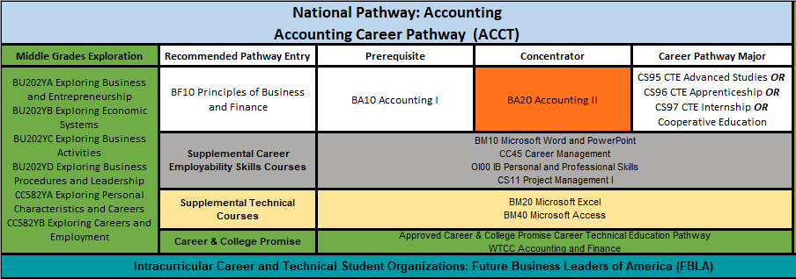

PRINCIPLES OF BUSINESS AND FINANCE BF102X0 1 Credit
Prerequisite: None
This course introduces students to topics related to business, finance, management, and marketing to cover business in the global economy, functions of business organization and management, marketing basics, and significance of business financial and risk management. English language arts, social studies, and mathematics are reinforced.
- Work Based Learning Opportunities: Apprenticeship: No Industry Field Trips: No Cooperative Education: No Entrepreneurial: No Internship: No Job Shadowing: Yes Mentorships: Yes School Based Enterprises: Yes Service Learning: Yes
- Aligned Industry Credential: None

ACCOUNTING I BA102X0 1 Credit
Prerequisite: None
This course is designed to help students understand the basic principles of the accounting cycle. Emphasis is placed on the analysis and recording of business transactions, preparation, and interpretation of financial statements, accounting systems, banking and payroll activities, basic types of business ownership, and an accounting career orientation. Mathematics is reinforced and entrepreneurial experiences are encouraged.
- Work Based Learning Opportunities: Apprenticeship: Yes Industry Field Trips: Yes Cooperative Education: Yes Entrepreneurial: Yes Internship: Yes Job Shadowing: Yes Mentorships: Yes School Based Enterprises: Yes Service Learning: Yes
- Aligned Industry Credential: None

ACCOUNTING I (HONORS) BA105X0 1 Credit
Prerequisite: None
In addition to the standard course requirements for Accounting I, this honors-level course extends the standard course of study to a more challenging level for the student who is highly motivated, able to work independently and has a history of high achievement. Honors credit will be awarded to students that successfully complete an Honors portfolio for the course that consists of college/career-themed projects and assessments.
- Work Based Learning Opportunities: Apprenticeship: Yes Industry Field Trips: Yes Cooperative Education: Yes Entrepreneurial: Yes Internship: Yes Job Shadowing: Yes Mentorships: Yes School Based Enterprises: Yes Service Learning: Yes
- Aligned Industry Credential: None

ACCOUNTING II (HONORS) BA205X0 1 Credit Prerequisite: BA10 Accounting I
This honors-level course is designed to provide students with an opportunity to develop in-depth knowledge of accounting procedures and techniques utilized in solving business problems and making financial decisions. Emphasis includes departmental accounting, corporate accounting, cost accounting, and inventory control systems, managerial accounting and budgeting, and further enhancement of accounting skills. Mathematics is reinforced and entrepreneurial experiences are encouraged.
- Work Based Learning Opportunities: Apprenticeship: Yes Industry Field Trips: Yes Cooperative Education: Yes Entrepreneurial: Yes Internship: Yes Job Shadowing: Yes Mentorships: Yes School Based Enterprises: Yes Service Learning: Yes
- Aligned Industry Credential: Intuit QuickBooks Certified User
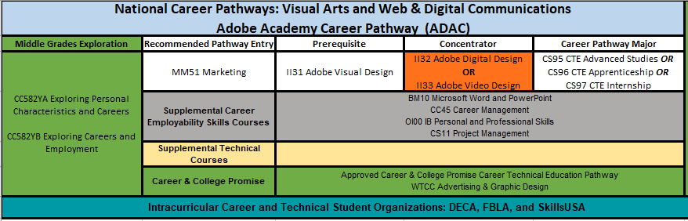

MARKETING MM512X0 1 Credit
Prerequisite: None
In this course, students develop an understanding of the processes involved from the creation to the consumption of products/services. Students develop an understanding and skills in the areas of distribution, marketing-information management, market planning, pricing, product/service management, promotion, and selling. Students develop an understanding of marketing functions and impact on business operations. Mathematics and social studies are reinforced.
- Work-Based Learning Opportunities: Apprenticeship: No Industry Field Trips: Yes Cooperative Education: Yes Entrepreneurial: Yes Internship: Yes Job Shadowing: Yes Mentorships: Yes School-Based Enterprises: Yes Service Learning: Yes
- Aligned Industry Credential: None

ADOBE VISUAL DESIGN II312X0 1 Credit
Prerequisite: None
This course is a project-based course that develops ICT, career, and communication skills in print and graphic design using Adobe tools. This course is aligned to Adobe Photoshop, InDesign, and Illustrator certification. English language arts are reinforced.
- Work Based Learning Opportunities: Apprenticeship: No Industry Field Trips: Yes Cooperative Education: Yes Entrepreneurial: No Internship: No Job Shadowing: No Mentorships: No School Based Enterprises: No Service Learning: No
- Aligned Industry Credential: Adobe Photoshop, InDesign, Illustrator

ADOBE VISUAL DESIGN (HONORS) II315X0 1 Credit
Prerequisite: None
In addition to the standard course requirements for Adobe Visual Design, this honors-level course extends the standard course of study to a more challenging level for the student who is highly motivated, able to work independently, and has a history of high academic achievement. Honors credit will be awarded to students that successfully complete an Honors portfolio for the course that consists of college/career-themed projects and assessments.
- Work Based Learning Opportunities: Apprenticeship: No Industry Field Trips: Yes Cooperative Education: Yes Entrepreneurial: No Internship: No Job Shadowing: No Mentorships: No School Based Enterprises: No Service Learning: No
- Aligned Industry Credential: Adobe Photoshop, InDesign, Illustrator

ADOBE DIGITAL DESIGN II322X0 1 Credit
Prerequisite: II31 Adobe Visual Design
This course is a project-based course that develops ICT, career, and communication skills in Web design using Adobe tools. This course is aligned to Adobe Dreamweaver and Flash certification. English language arts are reinforced.
- Work Based Learning Opportunities: Apprenticeship: Yes Industry Field Trips: No Cooperative Education: Yes Entrepreneurial: No Internship: No Job Shadowing: Yes Mentorships: No School Based Enterprises: No Service Learning: No
- Aligned Industry Credential: Adobe Dreamweaver

ADOBE DIGITAL DESIGN (HONORS) II325X0 1 Credit
Prerequisite: II31 Adobe Visual Design
In addition to the standard course requirements for Adobe Digital Design, this honors-level course extends the standard course of study to a more challenging level for the student who is highly motivated, able to work independently, and has a history of high academic achievement. Honors credit will be awarded to students that successfully complete an Honors portfolio for the course that consists of college/career-themed projects and assessments.
- Work Based Learning Opportunities: Apprenticeship: Yes Industry Field Trips: No Cooperative Education: Yes Entrepreneurial: No Internship: No Job Shadowing: Yes Mentorships: No School Based Enterprises: No Service Learning: No
- Aligned Industry Credential: Adobe Dreamweaver

ADOBE VIDEO DESIGN II332X0 1 Credit
Prerequisite: II31 Adobe Visual Design
This course is a project-based video course that develops career and communication skills in video production using Adobe tools. This course is aligned to Adobe Premiere certification. English language arts are reinforced.
- Work Based Learning Opportunities: Apprenticeship: Yes Industry Field Trips: No Cooperative Education: Yes Entrepreneurial: No Internship: No Job Shadowing: Yes Mentorships: No School Based Enterprises: No Service Learning: No
- Aligned Industry Credential: Adobe Premiere

ADOBE VIDEO DESIGN (HONORS) II335X0 1 Credit
Prerequisite: II31 Adobe Visual Design
In addition to the standard course requirements for Adobe Video Design, this honors-level course extends the standard course of study to a more challenging level for the student who is highly motivated, able to work independently, and has a history of high academic achievement. Honors credit will be awarded to students that successfully complete an Honors portfolio for the course that consists of college/career-themed projects and assessments.
- Work Based Learning Opportunities: Apprenticeship: Yes Industry Field Trips: No Cooperative Education: Yes Entrepreneurial: No Internship: No Job Shadowing: Yes Mentorships: No School Based Enterprises: No Service Learning: No
- Aligned Industry Credential: Adobe Premiere

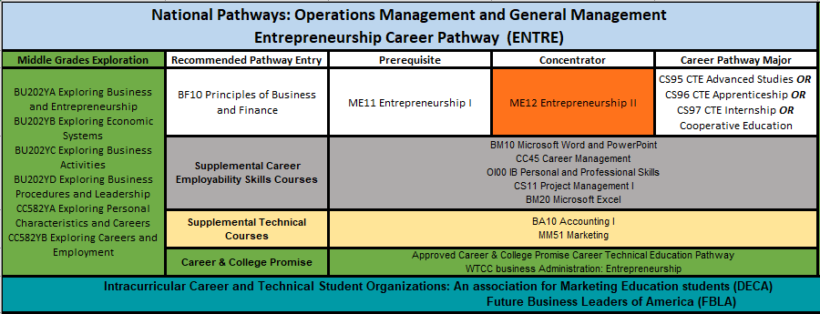

PRINCIPLES OF BUSINESS AND FINANCE BF102X0 1 Credit
Prerequisite: None
This course introduces students to topics related to business, finance, management, and marketing to cover business in the global economy, functions of business organization and management, marketing basics, and significance of business financial and risk management. English language arts, social studies, and mathematics are reinforced.
- Work Based Learning Opportunities: Apprenticeship: No Industry Field Trips: No Cooperative Education: No Entrepreneurial: No Internship: No Job Shadowing: Yes Mentorships: Yes School Based Enterprises: Yes Service Learning: Yes
- Aligned Industry Credential: None

ENTREPRENEURSHIP I ME112X0 1 Credit
Prerequisite: None
In this course, students evaluate the concepts of going into business for themselves and working for or operating a small business. Emphasis is on the exploration of feasible ideas of products/services, research procedures, business financing, marketing strategies, and access to resources for starting a small business. Students develop components of a business plan and evaluate startup requirements. English language arts and social studies are reinforced.
- Work Based Learning Opportunities: Apprenticeship: No Industry Field Trips: Yes Cooperative Education: Yes Entrepreneurial: Yes Internship: Yes Job Shadowing: Yes Mentorships: Yes School Based Enterprises: Yes Service Learning: Yes
- Aligned Industry Credential: Venture Entrepreneurial Expedition

ENTREPRENEURSHIP I (HONORS) ME115X0 1 Credit
Prerequisite: None
In addition to the standard course requirements for Entrepreneurship I, this honors-level course extends the standard course of study to a more challenging level for the student who is highly motivated, able to work independently, and has a history of high academic achievement. Honors credit will be awarded to students that successfully complete an Honors portfolio for the course that consists of college/career-themed projects and assessments.
- Work Based Learning Opportunities: Apprenticeship: No Industry Field Trips: Yes Cooperative Education: Yes Entrepreneurial: Yes Internship: Yes Job Shadowing: Yes Mentorships: Yes School Based Enterprises: Yes Service Learning: Yes
- Aligned Industry Credential: Venture Entrepreneurial Expedition

ENTREPRENEURSHIP II (HONORS) ME125X0 1 Credit
Prerequisite: ME11 Entrepreneurship I
In this honors-level course students develop an understanding of pertinent decisions to be made after obtaining financing to open a small business. Students acquire in-depth understanding of business regulations, risks, management, and marketing. Students develop a small-business management handbook. Students that successfully complete this course will earn Honors credit. English language arts and social studies are reinforced.
- Work Based Learning Opportunities: Apprenticeship: No Industry Field Trips: Yes Cooperative Education: Yes Entrepreneurial: Yes Internship: Yes Job Shadowing: Yes Mentorships: Yes School Based Enterprises: Yes Service Learning: Yes
- Aligned Industry Credential: Concepts of Entrepreneurship, Venture Entrepreneurial Expedition, Entrepreneurship and Small Business

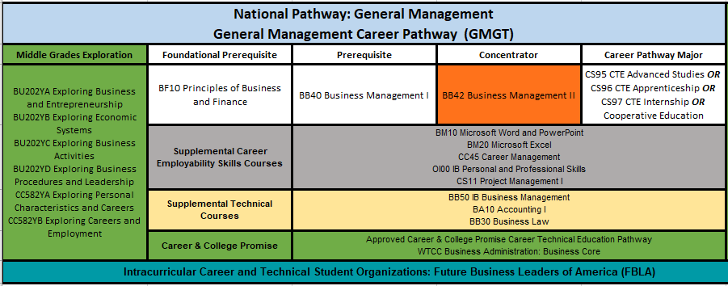

PRINCIPLES OF BUSINESS AND FINANCE BF102X0 1 Credit
Prerequisite: None
This course introduces students to topics related to business, finance, management, and marketing to cover business in the global economy, functions of business organization and management, marketing basics, and significance of business financial and risk management. English language arts, social studies, and mathematics are reinforced.
- Work Based Learning Opportunities: Apprenticeship: No Industry Field Trips: No Cooperative Education: No Entrepreneurial: No Internship: No Job Shadowing: Yes Mentorships: Yes School Based Enterprises: Yes Service Learning: Yes
- Aligned Industry Credential: None

BUSINESS MANAGEMENT I BB402X0 1 Credit
Prerequisite: BF10 Principles of Business and Finance
This course is designed to introduce students to core management concepts. The experience includes how managers plan, organize, staff, and direct the business’s resources that enhance the effectiveness of the decision-making process. Also, the experience includes students working through ethical dilemmas and problem-solving situations with customer service while academic and critical-thinking skills. English language arts is reinforced.
- Work Based Learning Opportunities: Apprenticeship: Yes Industry Field Trips: Yes Cooperative Education: Yes Entrepreneurial: Yes Internship: Yes Job Shadowing: Yes Mentorships: Yes School Based Enterprises: Yes Service Learning: Yes
- Aligned Industry Credential: None

BUSINESS MANAGEMENT II BB422X0 1 Credit
Prerequisite: BB40 Business Management I
This course is designed to enable students to acquire, understand, and appreciate the significance of management to business organizations. Understanding how managers control financial resources, inventory, ensure employee safety, and protect customer data enhances the effectiveness of their decision making. Students will work through ethical dilemmas, practice problem solving, and enhance their teamwork skills. English language arts and mathematics are reinforced.
- Work Based Learning Opportunities: Apprenticeship: Yes Industry Field Trips: Yes Cooperative Education: Yes Entrepreneurial: Yes Internship: Yes Job Shadowing: Yes Mentorships: Yes School Based Enterprises: Yes Service Learning: Yes
- Aligned Industry Credential: None

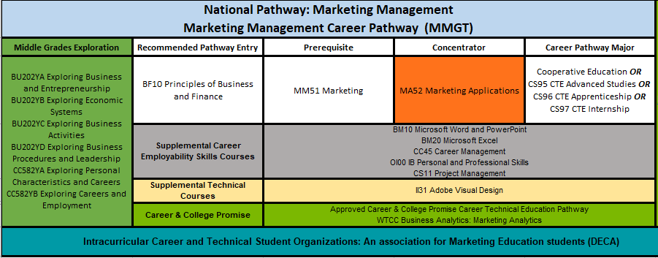

PRINCIPLES OF BUSINESS AND FINANCE BF102X0 1 Credit
Prerequisite: None
This course introduces students to topics related to business, finance, management, and marketing to cover business in the global economy, functions of business organization and management, marketing basics, and significance of business financial and risk management. English language arts, social studies, and mathematics are reinforced.
- Work Based Learning Opportunities: Apprenticeship: No Industry Field Trips: No Cooperative Education: No Entrepreneurial: No Internship: No Job Shadowing: Yes Mentorships: Yes School Based Enterprises: Yes Service Learning: Yes
- Aligned Industry Credential: None

MARKETING MM512X0 1 Credit
Prerequisite: None
In this course, students develop an understanding of the processes involved from the creation to the consumption of products/services. Students develop an understanding and skills in the areas of distribution, marketing-information management, market planning, pricing, product/service management, promotion, and selling. Students develop an understanding of marketing functions and impact on business operations. Mathematics and social studies are reinforced.
- Work-Based Learning Opportunities: Apprenticeship: No Industry Field Trips: Yes Cooperative Education: Yes Entrepreneurial: Yes Internship: Yes Job Shadowing: Yes Mentorships: Yes School-Based Enterprises: Yes Service Learning: Yes
- Aligned Industry Credential: None

MARKETING APPLICATIONS MA522X0 1 Credit
Prerequisite: MM51 Marketing or MI21 Fashion Merchandising
In this course, students will apply an understanding of marketing functions and impact of the functions on business decisions. Through problem solving and critical thinking, students will apply knowledge and skills in the areas of customer relations, economics, financial analysis, channel management, marketing- information management, marketing planning, products and services management, and selling. Relative opportunities are available for students to use technology to acquire and use marketing information. English, language arts, and social studies are reinforced.
- Work Based Learning Opportunities: Apprenticeship: No Industry Field Trips: Yes Cooperative Education: Yes Entrepreneurial: Yes Internship: Yes Job Shadowing: Yes Mentorships: Yes School Based Enterprises: Yes Service Learning: Yes
- Aligned Industry Credential: Customer Service and Sales Certification, Advance Customer Service and Sales Certification, Fundamental Marketing Concepts

MARKETING APPLICATIONS (HONORS) MA525X0 1 Credit Prerequisite: MM51 Marketing or MI21 Fashion Merchandising
In addition to the standard course requirements for Marketing Applications, this honors-level course extends the standard course of study to a more challenging level
for the student who is highly motivated, able to work independently and has a history of high academic achievement. Honors credit will be awarded to students that
successfully complete an Honors portfolio for the course that consists of college/career-themed projects and assessments.
- Work Based Learning Opportunities: Apprenticeship: No Industry Field Trips: Yes Cooperative Education: Yes Entrepreneurial: Yes Internship: Yes Job Shadowing: Yes Mentorships: Yes School Based Enterprises: Yes Service Learning: Yes
- Aligned Industry Credential: Customer Service and Sales Certification, Advance Customer Service and Sales Certification, Fundamental Marketing Concepts

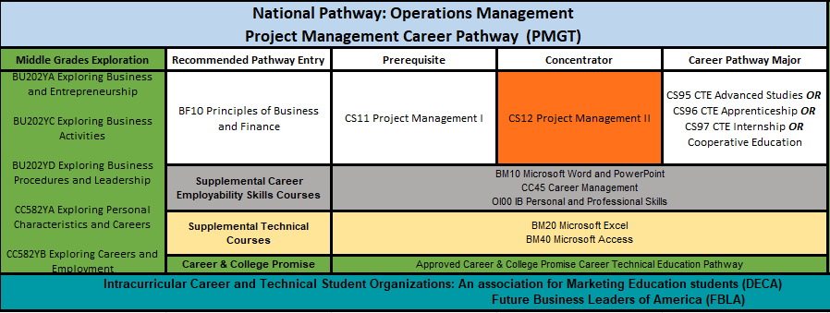

PRINCIPLES OF BUSINESS AND FINANCE BF102X0 1 Credit
Prerequisite: None
This course introduces students to topics related to business, finance, management, and marketing to cover business in the global economy, functions of business organization and management, marketing basics, and significance of business financial and risk management. English language arts, social studies, and mathematics are reinforced.
- Work Based Learning Opportunities: Apprenticeship: No Industry Field Trips: No Cooperative Education: No Entrepreneurial: No Internship: No Job Shadowing: Yes Mentorships: Yes School Based Enterprises: Yes Service Learning: Yes
- Aligned Industry Credential: None

PROJECT MANAGEMENT I CS112X0 1 Credit
Prerequisite: None
This course will introduce students to the principles, concepts, and software applications used in the management of projects. Through project-based learning, students will understand how to use the framework of initiating, planning, executing, monitoring and controlling, and closing a project in authentic situations. The core concepts of scope, time, cost, and integration will be examined during this course.
- Work Based Learning Opportunities: Apprenticeship: No Industry Field Trips: No Cooperative Education: Yes Entrepreneurial: Yes Internship: Yes Job Shadowing: Yes Mentorships: Yes School Based Enterprises: Yes Service Learning: Yes
- Aligned Industry Credential: None

PROJECT MANAGEMENT II CS122X0 1 Credit
Prerequisite: CS11 Project Management I
This project-based course focuses on the use of information technology to increase the effectiveness and efficiency of project management and integrated enterprise. Students will learn operational strategies for managing advanced technology and innovation as well as how to map the high technology operations environment to business settings. Art, English language arts, and mathematics are reinforced.
- Work-Based Learning Opportunities: Apprenticeship: No Industry Field Trips: No Cooperative Education: Yes Entrepreneurial: Yes Internship: Yes Job Shadowing: Yes Mentorships: Yes School-Based Enterprises: Yes Service Learning: Yes
- Aligned Industry Credential: None

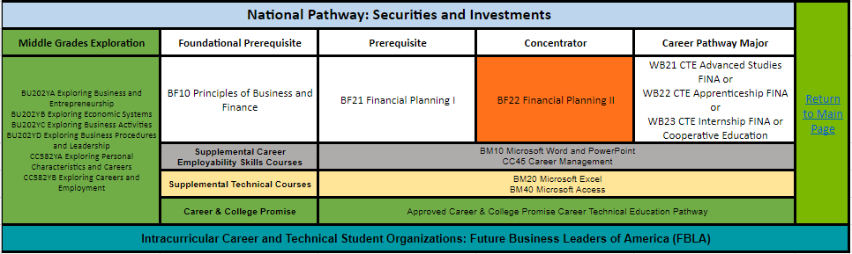

PRINCIPLES OF BUSINESS AND FINANCE BF102X0 1 Credit
Prerequisite: None
This course introduces students to topics related to business, finance, management, and marketing to cover business in the global economy, functions of business organization and management, marketing basics, and significance of business financial and risk management. English language arts, social studies, and mathematics are reinforced.
- Work Based Learning Opportunities: Apprenticeship: No Industry Field Trips: No Cooperative Education: No Entrepreneurial: No Internship: No Job Shadowing: Yes Mentorships: Yes School Based Enterprises: Yes Service Learning: Yes
- Aligned Industry Credential: None

FINANCIAL PLANNING I BF212X0 1 Credit Prerequisite: BF10 Principles of Business and Finance
This course is designed to cover key strategies for wealth building as students learn to evaluate businesses for investment opportunities while incorporating current headlines and trends, financial resources, and stock market simulation. Also students will develop techniques to enhance personal wealth building for a secure financial future. Current technology will be used to acquire information and to complete activities. Throughout the course, students are presented ethical dilemmas and problem-solving situations for which they must apply academic, team-building and critical-thinking skills.
- Work Based Learning Opportunities: Apprenticeship: No Industry Field Trips: Yes Cooperative Education: No Entrepreneurial: No Internship: No Job Shadowing: Yes Mentorships: Yes School Based Enterprises: No Service Learning: Yes
- Aligned Industry Credential: None

FINANCIAL PLANNING II BF222X0 1 Credit
Prerequisite: BF21 Financial Planning I
Students will further develop the fundamental knowledge and skills acquired in Wealth Building to create a business financial plan; including loans, insurance, taxes, corporate governance, and explore the various risks and returns associated with business activities. Emphasis will be placed on analyzing ethical situations in various aspects of finance in local, national and global business environments. Current technology will be used to acquire information and to complete activities. Throughout the course, students are presented ethical dilemmas and problem-solving situations for which they must apply academic, team-building and critical-thinking skills.
- Work Based Learning Opportunities: Apprenticeship: No Industry Field Trips: Yes Cooperative Education: No Entrepreneurial: No Internship: No Job Shadowing: Yes Mentorships: Yes School Based Enterprises: No Service Learning: Yes
- Aligned Industry Credential: None

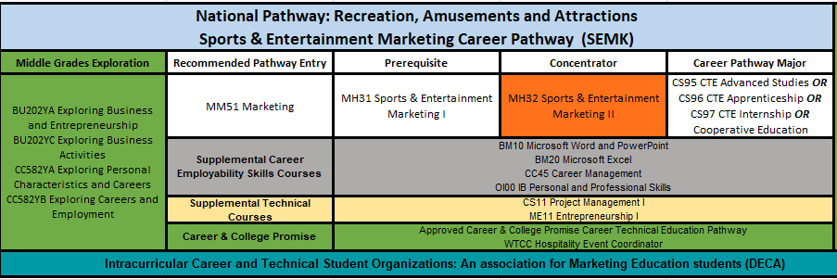

MARKETING MM512X0 1 Credit
Prerequisite: None
In this course, students develop an understanding of the processes involved from the creation to the consumption of products/services. Students develop an understanding and skills in the areas of distribution, marketing-information management, market planning, pricing, product/service management, promotion, and selling. Students develop an understanding of marketing functions and impact on business operations. Mathematics and social studies are reinforced.
- Work-Based Learning Opportunities: Apprenticeship: No Industry Field Trips: Yes Cooperative Education: Yes Entrepreneurial: Yes Internship: Yes Job Shadowing: Yes Mentorships: Yes School-Based Enterprises: Yes Service Learning: Yes
- Aligned Industry Credential: None

SPORTS AND ENTERTAINMENT MARKETING I MH312X0 1 Credit
Prerequisite: None
In this course, students are introduced to the industry of sports, entertainment, and event marketing. Students acquire transferable knowledge and skills among related industries for planning sports, entertainment, and event marketing. Topics included are branding, licensing, and naming rights, business foundations, concessions and on-site merchandising, economic foundations, human relations, and safety and security. Mathematics and social studies are reinforced.
- Work Based Learning Opportunities: Apprenticeship: No Industry Field Trips: Yes Cooperative Education: Yes Entrepreneurial: Yes Internship: Yes Job Shadowing: Yes Mentorships: Yes School Based Enterprises: Yes Service Learning: Yes
- Aligned Industry Credential: None

SPORTS AND ENTERTAINMENT MARKETING II (HONORS) MH325X0 1 Credit
Prerequisite: MH31 Sports and Entertainment Marketing I
In this course, students acquire an understanding of selling, promotion, and market planning of sports, entertainment, and event marketing. Emphasis is on business management, career development, client relations, contracts, ethics, event management, facilities management, legal issues, and sponsorships. English/language arts, mathematics and social studies are reinforced.
- Work Based Learning Opportunities: Apprenticeship: No Industry Field Trips: Yes Cooperative Education: Yes Entrepreneurial: Yes Internship: Yes Job Shadowing: Yes Mentorships: Yes School Based Enterprises: Yes Service Learning: Yes
- Aligned Industry Credential: Customer Service and Sales Certification, Advance Customer Service and Sales Certification, Fundamental Marketing Concepts

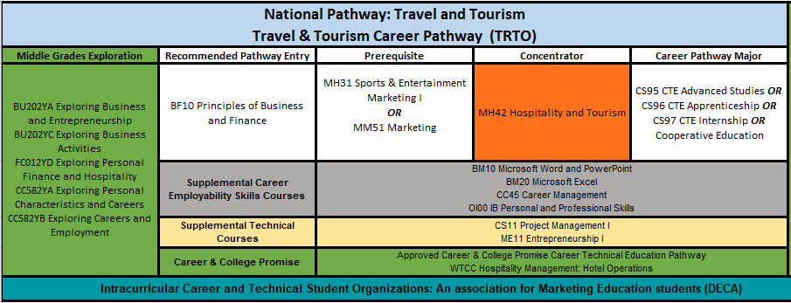

PRINCIPLES OF BUSINESS AND FINANCE BF102X0 1 Credit
Prerequisite: None
This course introduces students to topics related to business, finance, management, and marketing to cover business in the global economy, functions of business organization and management, marketing basics, and significance of business financial and risk management. English language arts, social studies, and mathematics are reinforced.
- Work Based Learning Opportunities: Apprenticeship: No Industry Field Trips: No Cooperative Education: No Entrepreneurial: No Internship: No Job Shadowing: Yes Mentorships: Yes School Based Enterprises: Yes Service Learning: Yes
- Aligned Industry Credential: None

MARKETING MM512X0 1 Credit
Prerequisite: None
In this course, students develop an understanding of the processes involved from the creation to the consumption of products/services. Students develop an understanding and skills in the areas of distribution, marketing-information management, market planning, pricing, product/service management, promotion, and selling. Students develop an understanding of marketing functions and impact on business operations. Mathematics and social studies are reinforced.
- Work-Based Learning Opportunities: Apprenticeship: No Industry Field Trips: Yes Cooperative Education: Yes Entrepreneurial: Yes Internship: Yes Job Shadowing: Yes Mentorships: Yes School-Based Enterprises: Yes Service Learning: Yes
- Aligned Industry Credential: None

SPORTS AND ENTERTAINMENT MARKETING I MH312X0 1 Credit
Prerequisite: None
In this course, students are introduced to the industry of sports, entertainment, and event marketing. Students acquire transferable knowledge and skills among related industries for planning sports, entertainment, and event marketing. Topics included are branding, licensing, and naming rights, business foundations, concessions and on-site merchandising, economic foundations, human relations, and safety and security. Mathematics and social studies are reinforced.
- Work Based Learning Opportunities: Apprenticeship: No Industry Field Trips: Yes Cooperative Education: Yes Entrepreneurial: Yes Internship: Yes Job Shadowing: Yes Mentorships: Yes School Based Enterprises: Yes Service Learning: Yes
- Aligned Industry Credential: None

HOSPITALITY AND TOURISM MH422X0 1 Credit
Prerequisite: MM51 Marketing or BF10 Principles of Business and Finance or MH31 Sports and Entertainment Marketing I
In this course, students acquire understanding of the economic impact and marketing strategies for hospitality and tourism destinations. Emphasis is on destination complexity, customer relations, economics, legal and ethical responsibilities, safety and security, and tourism promotion. English language arts, mathematics, social studies and technology are reinforced.
- Work Based Learning Opportunities: Apprenticeship: No Industry Field Trips: Yes Cooperative Education: Yes Entrepreneurial: Yes Internship: Yes Job Shadowing: Yes Mentorships: Yes School Based Enterprises: Yes Service Learning: Yes
- Aligned Industry Credential: Advanced Customer Service and Sales Certification, Fundamental Marketing Concepts, or Certified Guest Service Professional (CGSP)

HOSPITALITY AND TOURISM (HONORS) MH425X0 1 Credit
Prerequisite: MM51 Marketing or BF10 Principles of Business and Finance or MH31 Sports and Entertainment Marketing I
In addition to the standard course requirements for Hospitality and Tourism, this honors-level course extends the standard course of study to a more challenging level for the student who is highly motivated, able to work independently, and has a history of high academic achievement. Honors credit will be awarded to students that successfully complete an Honors portfolio for the course that consists of college/career-themed projects and assessments.
- Work Based Learning Opportunities: Apprenticeship: No Industry Field Trips: Yes Cooperative Education: Yes Entrepreneurial: Yes Internship: Yes Job Shadowing: Yes Mentorships: Yes School Based Enterprises: Yes Service Learning: Yes
- Aligned I Industry Credential: Advanced Customer Service and Sales Certification, Fundamental Marketing Concepts, or Certified Guest Service Professional (CGSP)
Wake Technical Community College Certificate / Course Descriptions

Business Administration

BUS-110: Introduction to Business
This course provides a survey of the business world. Topics include the basic principles and practices of contemporary business. Upon completion, students should be able to demonstrate an understanding of business concepts as a foundation for studying other business subjects.

BUS-139: Entrepreneurship 1
This course provides an introduction to the principles of entrepreneurship. Topics include self-analysis of entrepreneurship readiness, the role of entrepreneur in economic development, legal problems, organizational structure, sources of financing, budgeting, and cash flow. Upon completion, students should have an understanding of the entrepreneurial process and issues faced by entrepreneurs.

BUS-230: Small Business Management
This course introduces the challenges of entrepreneurship including the startup and operation of a small business. Topics include market research techniques, feasibility studies, site analysis, financing alternatives, and managerial decision making. Upon completion, students should be able to develop a small business plan.

MKT -120: Principles of Marketing
This course introduces principles and problems of marketing goods and services. Topics include promotion, placement, and pricing strategies for products. Upon completion, students should be able to apply marketing principles in organizational decision making.

BUS-137: Principles of Management
This course is designed to be an overview of the major functions of management. Emphasis is placed on planning, organizing, controlling, directing, and communicating. Upon completion, students should be able to work as contributing members of a team utilizing these functions of management.

BUS-153: Human Resources Management
This course introduces the functions of personnel/human resource management within an organization. Topics include equal opportunity and the legal environment, recruitment and selection, performance appraisal, employee development, compensation planning, and employee relations. Upon completion, students should be able to anticipate and resolve human resource concerns.

BUS-240: Business Ethics
This course introduces contemporary and controversial ethical issues that face the business community. Topics include moral reasoning, moral dilemmas, law and morality, equity, justice and fairness, ethical standards, and moral development. Upon completion, students should be able to demonstrate an understanding of their moral responsibilities and obligations as members of the workforce and society.

BUS-255: Organizational Behavior in Business
This course covers the impact of different management practices and leadership styles on worker satisfaction and morale, organizational effectiveness, productivity, and profitability. Topics include a discussion of formal and informal organizations, group dynamics, motivation, and managing conflict and change. Upon completion, students should be able to analyze different types of interpersonal situations and determine and appropriate course of action.

Culinary Arts

CUL-110: Sanitation and Safety
This course introduces the basic principles of sanitation and safety relative to the hospitality industry. Topics include personal hygiene, sanitation and safety regulations, use and care of equipment, the principles of food-borne illness, and other related topics. Upon completion, students should be able to demonstrate an understanding of the content necessary for successful completion of a nationally recognized food/safety/sanitation exam.

CUL-112: Nutrition for Food Service
This course covers the principles of nutrition and its relationship to the foodservice industry. Topics include personal nutrition fundamentals, weight management, exercise, nutritional adaptation/analysis of recipes/menus, healthy cooking techniques and marketing nutrition in a foodservice operation. Upon completion, students should be able to apply basic nutritional concepts to food preparation and selection.

CUL-130: Menu Design
This course introduces menu design and its relationship to foodservice operations. Topics include layout, marketing, concept development, dietary concerns, product utilization, target consumers and trends. Upon completion, students should be able to design, create and produce menus for a variety of foodservice settings.

CUL-140: Culinary Skills I
This course introduces the fundamental concepts, skills and techniques in basic cookery, and moist, dry and combination heat. Emphasis is placed on recipe conversion, measurements, terminology, classical knife cuts, safe food/equipment handling, flavorings/seasonings, stocks/sauces/soups, and related topics. Upon completion, students should be able to exhibit the basic cooking skills used in the foodservice industry.
HRM-245: Human Resource Management Hospitality
This course introduces a systematic approach to human resource management in the hospitality industry. Topics include training/development, staffing, selection, hiring, recruitment, evaluation, benefit administration, employee relations, labor regulations/laws, discipline, motivation, productivity, shift management, contract employees and organizational culture. Upon completion, students should be able to apply human resource management skills for the hospitality industry.

CUL-170: Garde Manger I
This course introduces basic cold food preparation techniques and pantry production. Topics include salads, sandwiches, appetizers, dressings, basic garnishes, cheeses, cold sauces, and related food items. Upon completion, students should be able to present a cold food display and exhibit an understanding of the cold kitchen and its related terminology.

CUL-240: Culinary Skills II
This course is designed to further students' knowledge of the fundamental concepts, skills, and techniques involved in basic cookery. Emphasis is placed on meat identification/fabrication, butchery and cooking techniques/methods; appropriate vegetable/starch accompaniments; compound sauces; plate presentation; breakfast cookery; and quantity food preparation. Upon completion, students should be able to plan, execute, and successfully serve entrees with complementary side items.

CUL-160: Baking I
This course covers basic ingredients, techniques, weights and measures, baking terminology and formula calculations. Topics include yeast/chemically leavened products, laminated doughs, pastry dough batter, pies/tarts, meringue, custard, cakes and cookies, icings, glazes and basic sauces. Upon completion, students should be able to demonstrate proper scaling and measurement techniques, and prepare and evaluate a variety of bakery products
Early Childhood Education

EDU-119: Introduction to Early Childhood Education
This course introduces the foundations of early childhood education, the diverse educational settings for young children, professionalism and planning intentional developmentally appropriate experiences for each child. Topics include theoretical foundations, national early learning standards, NC Foundations for Early Learning and Development, state regulations, program types, career options, professionalism, ethical conduct, quality inclusive environments, and curriculum responsive to the needs of each child/family. Upon completion, students should be able to design a career/professional development plan, appropriate environments, schedules, and activity plans.

EDU-131: Child, Family, and Community
This course covers the development of partnerships between culturally and linguistically diverse families, children, schools and communities. Emphasis is placed on developing skills and identifying benefits for establishing, supporting, and maintaining respectful, collaborative relationships between diverse families, programs/schools, and community agencies/resources. Upon completion, students should be able to explain appropriate relationships between families, educators, and professionals that enhance development and educational experiences of all children.

EDU-144: Child Development I
This course includes the theories of child development, needs, milestones, and factors that influence development, from conception through approximately 36 months. Emphasis is placed on developmental sequences in physical/motor, emotional/social, cognitive, and language domains and the impact of multiple influences on development and learning. Upon completion, students should be able to compare/contrast typical/atypical developmental characteristics, explain environmental factors that impact development, and identify strategies for enhancing development.

EDU-145: Child Development II
This course includes the theories of child development, observation and assessment, milestones, and factors that influence development, from preschool through middle childhood. Emphasis is placed on knowledge, observation and assessment of developmental sequences in approaches to play/learning, emotional/social, health/physical, language/communication and cognitive domains. Upon completion, students should be able to compare/contrast typical/atypical developmental characteristics, explain biological and environmental factors that impact development, and identify evidence-based strategies for enhancing development for children that are culturally, linguistically, and ability diverse.

EDU-146: Child Guidance
This course introduces principles and practical techniques including the design of learning environments for providing developmentally appropriate guidance for all children, including those at risk. Emphasis is placed on observation skills, cultural influences, underlying causes of behavior, appropriate expectations, development of self control and the role of communication and guidance. Upon completion, students should be able to demonstrate direct/indirect strategies for preventing problem behaviors, teaching appropriate/acceptable behaviors, negotiation, setting limits and recognizing at risk behaviors.

EDU-153: Health, Safety, and Nutrition
This course covers promoting and maintaining the health and well-being of all children. Topics include health and nutritional guidelines, common childhood illnesses, maintaining safe and healthy learning environments, recognition and reporting of abuse and neglect and state regulations. Upon completion, students should be able to demonstrate knowledge of health, safety, and nutritional needs, safe learning environments, and adhere to state regulations.

EDU-151: Creative Activities
This course introduces developmentally supportive creative learning environments with attention to divergent thinking, creative problem-solving, evidence-based teaching practices, and open-ended learning materials while applying NC Foundations for Early Learning and Development. Emphasis is placed on observation of process driven learning experiences in art, music, creative movement, dance, and dramatics for every young child age birth through eight, integrated through all domains and academic content. Upon completion, students should be able to examine, create, and adapt developmentally creative learning materials, experiences, and environments for children that are culturally, linguistically, and ability diverse.

EDU–221: Children with Exceptionalities
This course covers atypical patterns of child development, inclusive/diverse settings, evidenced-based educational/family plans, differentiated instruction, adaptive materials, and assistive technology. Emphasis is placed on the characteristics of exceptionalities and delays, early intervention/special education, transitions, observation, developmental screening, formative assessment of children, and collaborating with families and community partners. Upon completion, students should be able to recognize diverse abilities, describe the referral process, identify community resources, explain the importance of collaboration with families/professionals, and develop appropriate strategies/adaptations to support children in all environments with best practices as defined by laws, policies and the NC Foundations for Early Learning and Development.

EDU-234: Infants, Toddlers, and Twos
This course covers the development of high-quality, individualized, responsive/engaging relationships and experiences for infants, toddlers, and twos. Emphasis is placed on typical and atypical child development, positive early learning experiences, supporting and engaging diverse families, providing safe, warm and nurturing interactions, and the application of the NC Foundations for Early Learning and Development. Upon completion, students should be able to demonstrate responsive planning, respectful relationships and exposure to a variety of developmentally appropriate experiences/materials that support a foundation for healthy development and growth of culturally, linguistically and ability diverse children birth to 36 months.

Emergency Medical Science

BIO-168: Basic Anatomy and Physiology I
This course provides a comprehensive study of the anatomy and physiology of the human body. Topics include body organization, homeostasis, cytology, histology, and the integumentary, skeletal, muscular, and nervous systems and special senses. Upon completion, students should be able to demonstrate an in-depth understanding of principles of anatomy and physiology and their interrelationships. Laboratory exercises will include investigation of structural and functional aspects of the indicated organ systems.

BIO-169: Basic Anatomy and Physiology II
This course provides a continuation of the comprehensive study of the anatomy and physiology of the human body. Topics include the endocrine, cardiovascular, lymphatic, respiratory, digestive, urinary, and reproductive systems as well as metabolism, nutrition, acid-base balance, and fluid and electrolyte balance. Upon completion, students should be able to demonstrate an in-depth understanding of principles of anatomy and physiology and their interrelationships. Laboratory exercises will include investigation of structural and functional aspects of the indicated organ systems.

EMS-110A: EMT-Basic Part 1
This course introduces basic emergency medical care. Topics include preparatory, airway, patient assessment, medical emergencies, trauma, infants and children, and operations. Upon completion, students should be able to demonstrate the knowledge and skills necessary to achieve North Carolina State or National Registry EMT-Basic certification. This course is offered only for eligible high school students.

EMS-110B: EMT-Basic Part 2
This course introduces basic emergency medical care. Topics include preparatory, airway, patient assessment, medical emergencies, trauma, infants and children, and operations. Upon completion, students should be able to demonstrate the knowledge and skills necessary to achieve North Carolina State or National Registry EMT-Basic certification. This course is offered only for eligible high school students.

Information Technology (IT) – Technical Support

NOS-110: Operating Systems Concepts
This course introduces students to a broad range of operating system concepts, including installation and maintenance. Emphasis is place on operating system concepts, management, maintenance, and resources required. Upon completion of this course, students will have an understanding of OS concepts, installation, management, maintenance, using a variety of operating systems.

NOS-130: Windows Single User
This course introduces operating system concepts for single-user systems. Topics include hardware management, file and memory management, system configuration/optimization, and utilities. Upon completion, students should be able to perform operating systems functions at the support level in a single-user environment. This course introduces operating system concepts for single-user systems. Topics include hardware management, file and memory management, system configuration/optimization, and utilities. Upon completion, students should be able to perform operating systems functions at the support level in a single-user environment. This course is taught within the Microsoft IT Academy as a Microsoft Official Academic Course (MOAC).

NOS-230: Windows Administration 1
This course covers the installation and configuration of a Windows Server operating system. Emphasis is placed on the basic configuration of core network services, Active Directory and group policies. Upon completion, students should be able to install and configure a Windows Server operating system. This course covers the installation and configuration of a Windows Server operating system. Emphasis is placed on the basic configuration of core network services, Active Directory and group policies. Upon completion, students should be able to install and configure a Windows Server operating system. This course is taught within the Microsoft IT Academy as a Microsoft Official Academic Course (MOAC)

CTI-120: Network and Security Foundation
This course introduces students to the Network concepts, including networking terminology and protocols, local and wide area networks, and network standards. Emphasis is placed on securing information systems and the various implementation policies. Upon completion, students should be able to perform basic tasks related to networking mathematics, terminology, media and protocols.

CTS-120: Hardware/Software Support
This course covers the basic hardware of a personal computer, including installation, operations and interactions with software. Topics include component identification, memory-system, peripheral installation and configuration, preventive maintenance, hardware diagnostics/repair, installation and optimization of system software, commercial programs, system configuration, and device-drivers. Upon completion, students should be able to select appropriate computer equipment and software, upgrade/maintain existing equipment and software, and troubleshoot/repair non-functioning personal computers.

CTS-220: Advanced Hardware/Software Support
This course provides advanced knowledge and competencies in hardware and operating system technologies for computer technicians to support personal computers. Emphasis is placed on: configuring and upgrading; diagnosis and troubleshooting; as well as preventive maintenance of hardware and system software. Upon completion, students should be able to install, configure, diagnose, perform preventive maintenance, and maintain basic networking on personal computers.

CTS-272: Desktop Support Applications
This course is designed to prepare students for a foundation in Desktop Support certification in office productivity applications. Emphasis is placed on developing proficiency in the end-user support skills, processes, and procedures necessary to correctly support office productivity products. Upon completion, students should be able to prepare for industry-level certification and utilize advanced support tools toward resolving office productivity end-user problems.

